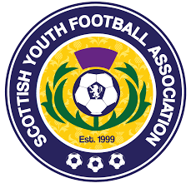

Confirmation of Attendance
SYFA AGM 20 June 2026
Name:
Position:
Email address:
Team name(s):
Team ID(s):
Club ID:
League:
I hereby confirm my intention to attend the SYFA AGM on 20 June 2026: | Signature*: _______________________________________  *can be typed
My attendance will be: (delete as appropriate) | In person  Online
If you have a question you would like to submit ahead of the AGM, please provide it here:

Completed forms should be emailed to syfa.board@scottish-football.com no later than 12 noon on Friday the 12th of June.
On receipt of your confirmation to attend, the SYFA will email you a link to register for the meeting via Zoom if applicable.

